Escuela Particular Las Naciones Nº1973
Avenida Las Naciones 800 Maipú
RBD : 25808-3 Fono: 7712401
Escuelalasnaciones1973@hotmail.com

ENGLISH GUIDE Nº2
UNIT 1 “Feelings and Opinions”
7TH GRADE

Name: ____________________________________________________Date: _______________

OA7:
Expresar opiniones, sentimientos de manera simple integrando los adjetivos relacionados a la unidad 1.
Contenidos:
- Feeling Adjectives
- Questions

Feeling Adjectives: Adjetivos de Sentimiento
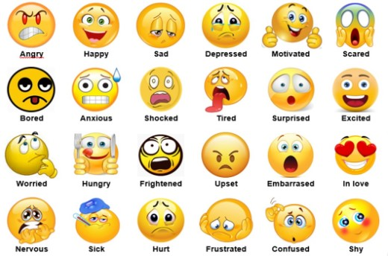

Questions: Preguntas

- WHY ARE YOU SAD?: ¿Por qué estas triste?
- WHAT IS THE MATTER?: ¿Cuál es el problema?
- WHAT IS WRONG?: ¿Qué está mal?
- ARE YOU FEELING ALRGHT?: ¿Te sientes bien?

Exercises:
1. Traduce cada concepto con la ayuda de un diccionario.

a. ANGRY: __________________________
b. HAPPY: __________________________
c. SAD: _____________________________
d. DEPRESSED: ______________________
e. MOTIVATED: ______________________
f. SCARED: __________________________
g. BORED: __________________________
h. ANXIOUS: ________________________
i. SHOCKED: ________________________
j. TIRED: ___________________________
k. SURPRISED: ______________________
l. EXCITED: _________________________
m. WORRIED: ________________________
n. HUNGRY: _________________________
o. FRIGHTENED: ______________________
p. UPSET: ___________________________
q. EMBARRASED: ____________________
r. IN LOVE: __________________________
s. NERVOUS: ________________________
t. SICK: ______________________________
u. HURT: ____________________________
v. FRUSTRATED: _____________________
w. CONFUSED: _______________________
x. SHY: ______________________________

2. Reordena las palabras para formar la pregunta correcta.

a. sad are you why?
____________________________________________________________________
b. matter is what the?
____________________________________________________________________
c. is wrong what?
____________________________________________________________________
d. feeling are alright you?
____________________________________________________________________

